Notes on building with Xcode for iOS: I used Xcode 5 (Developer Preview 3 – August 2013)

Open the XMLFoundation library project in Xcode.

[XMLFoundation\Libraries\XMLFoundation\Build\iOSXMLF\iOSXMLF.xcodeproj ]

Product/Scheme/Edit Scheme

Select “Run” on the left, and “Info” toward the top.

Here you should set the “Build Configuration” to Debug then close the dialog. Build the library – (Product/Build). Come back to the (Product/Scheme/Edit Scheme) dialog and set it to Release and build the library again to make a release build.

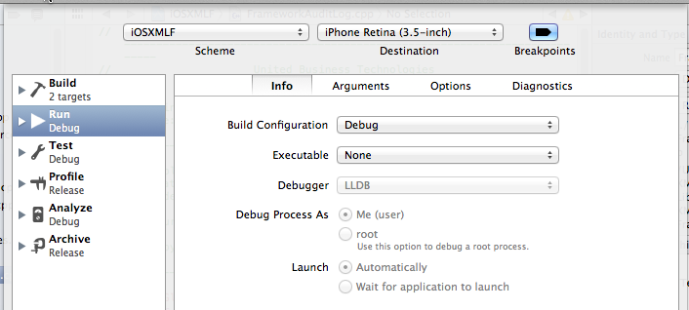

Also notice the “Destination “ at the top center. In the image above it is set to “iPhone Retine 3.5 –inch”. This value (specifically not “iOS Device”) required for a library build that runs in the iOS Simulator. I made one build for Debug on the iPhone, one for Release on the iPhone, and one for Debug in the iOS simulator. Below you see the results of the three times I built it.

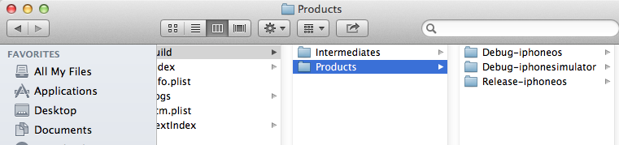

The build uses a native default Xcode configuration – therefore:

From “Finder” select menu item “Go” then “Go To Folder” enter the following:

~/Library/Developer/Xcode/DerivedData

Move down into the iOSXMLF* folder, then move down into “Build/Products”. You will use the “Debug-iphonesimulator”, if you test in the iOS Simulator.

Now that you have created the library……

Open the example project that will use the library you created.

\XMLFOUNDATION\Examples\Objective C\ObjectiveObjects\ObjectiveObjects.xcodeproj\project.pbxproj

On my machine the XMLFoundation library header files are installed at:

/Users/user/Desktop/XMLFoundation/Libraries/XMLFoundation/inc

You will need to set “Header Search Paths” to your own location to the same files:

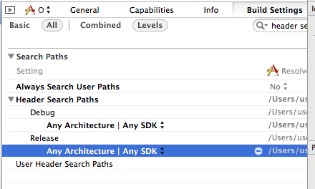

Now set the “Library Search Path”

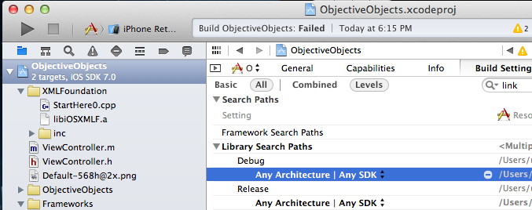

Set your Search path to where the libiOSXMLF.a file you just created is located

From “Finder” select menu item “Go” then “Go To Folder” enter the following:

~/Library/Developer/Xcode/DerivedData

Move down into the iOSXMLF* folder, then move down into “Build/Products”. You will use the “Debug-iphonesimulator”, if you test in the iOS Simulator.

Paste that path into your project library search path.

In the ObjectiveObjects sample, (Products/Destination) set the iOS Simulator iPhone Retina 3.5

Try to build the project.

If you get this error,

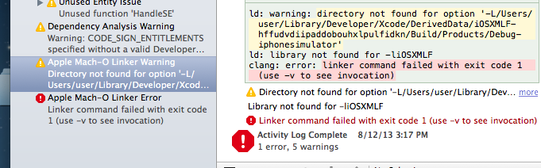

Double check that your “Library Search Path” points to the folder with the correct libiOSXMLF.a

In the future, when you add XMLFoundation into your own project – This is one way to do it:

From the Finder Window, drag libiOSXMLF.a into your project. Use the options shown below for adding the library file to your project.

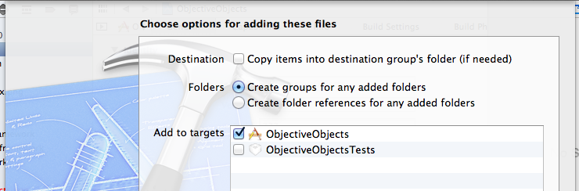

Then set “Header Search Paths”, and “Library Search Paths” as shown above.

Build your project. If you see the following “Missing required i386 architecture” errors:

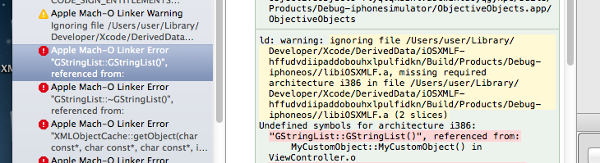

or

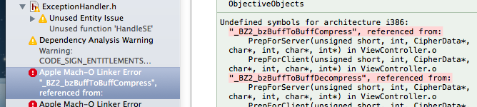

First, make sure you have the “Target Membership” checked for your project. Like this:

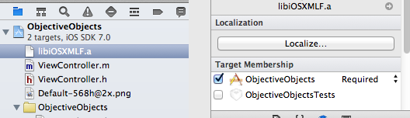

If that does not solve the problem, you likely need to hand edit project.pbxproj (located inside your project file bundle). In mine I had to delete everything from “LIBRARY_SEARCH_PATH” except for the one entry that is highlighted below (in the two sections it was found - Debug and Release)

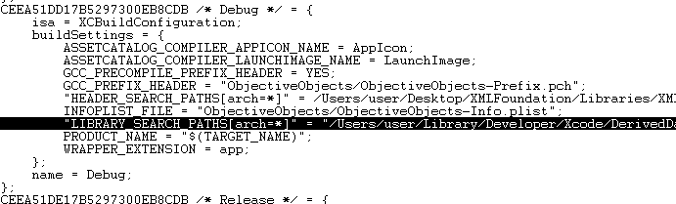

– If that entry is not there delete the entire LIBRARY_SEARCH_PATH section:

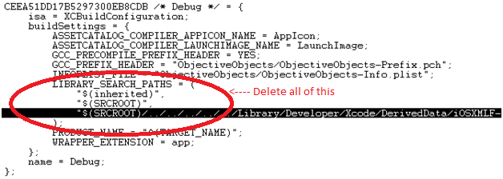

AND I had to delete the entire FRAMEWORK_SEARCH_PATH entry that occurs once for debug, and once for release. So DELETE the selected text shown below(delete it in two places):

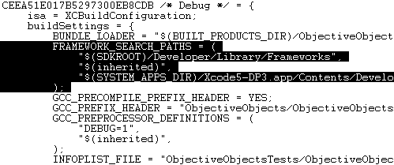

And finally, this is also another error that has a simple solution

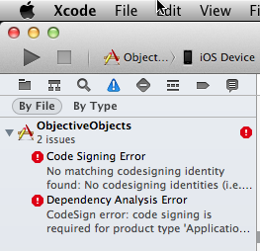

Change your “Product”🡪 “Destination” 🡪 to “iPhone Retina(3.5 Inch)” (an iOS Simulator device)